**PROJECT ON INSTAGRAM DATABASE**

Database – (Ig_clone)

1**) How many times does the average user post?**

**SELECT AVG(post_count) AS average_posts_per_user**

**FROM (**

**SELECT user_id, COUNT(*) AS post_count**

**FROM photos**

**GROUP BY user_id**

**) AS user_post_counts;**

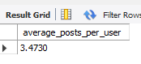

**2) Find the top 5 most used hashtags**

**select tag_name, count(tag_name) as total from tags t join photo_tags pt**

**on t.id = pt.tag_id**

**group by t.id order by total desc**

**limit 5;**

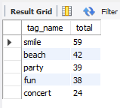

**3) Find users who have liked every single photo on the site**

**with cte_total_likes as (**

**select username, count(id) as total from users u**

**join likes l**

**on u.id = l.user_Id**

**group by u.id**

**)**

**select * from cte_total_likes where total =(select count(*) from photos);**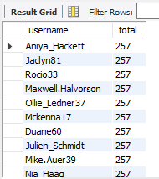

**4) Retrieve a list of users along with their usernames and**

**the rank of their account creation, ordered by the creation date in ascending order;**

**select user_id, username, users.created_at,**

**rank () over (order by users.created_at) as 'rank' from users**

**inner join photos on users.id = photos.user_id group by user_id, username ;**

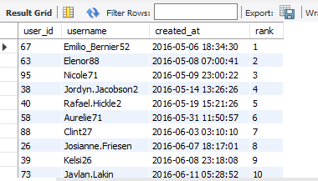

**5) List the comments made on photos with their comment texts, photo URLs, and usernames of users who posted the comments. Include the comment count for each photo;**

**WITH CommentCounts AS ( #CommentCounts CTE -- calculates the count of comments for each photo**

**SELECT**

**photo_id,**

**COUNT(comment_text) AS c_count**

**FROM**

**comments**

**GROUP BY**

**photo_id**

**),**

**PhotoComments AS ( #PhotoComments CTE - retrieves the username of the user who posted the comment,**

**SELECT -- the comment text, the photo URL, and the photo ID**

**u.username,**

**c.comment_text,**

**p.image_url,**

**c.photo_id**

**FROM**

**photos p**

**JOIN**

**comments c ON p.id = c.photo_id**

**JOIN**

**users u ON c.user_id = u.id**

**)**

**SELECT #Main Query -selects columns from the PhotoComments and CommentCounts CTEs**

**pc.username,**

**pc.comment_text,**

**pc.image_url,**

**cc.c_count**

**FROM**

**PhotoComments pc**

**JOIN**

**CommentCounts cc ON pc.photo_id = cc.photo_id;**

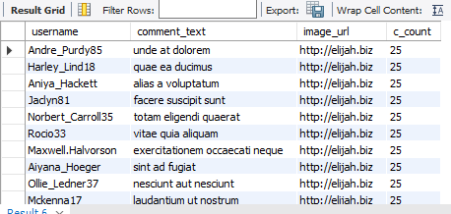

**6) For each tag, show the tag name and the number of photos associated with that tag. Rank the tags by the number of photos in descending order;**

**SELECT**

**tag_name,**

**num_photos,**

**RANK() OVER (ORDER BY num_photos DESC) AS tag_rank**

**FROM (**

**SELECT**

**t.tag_name,**

**COUNT(pt.photo_id) AS num_photos**

**FROM**

**tags t**

**LEFT JOIN**

**photo_tags pt ON t.id = pt.tag_id**

**GROUP BY**

**t.tag_name**

**) AS tag_counts;**

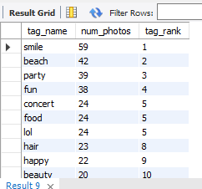

**7) List the usernames of users who have posted photos along with the count**

**of photos they have posted. Rank them by the number of photos in descending**

**order.**

**SELECT**

**username,**

**no_of_photos,**

**RANK() OVER (ORDER BY no_of_photos DESC) AS user_rank**

**FROM (**

**SELECT**

**u.username,**

**COUNT(p.id) AS no_of_photos**

**FROM**

**photos p**

**JOIN**

**users u ON p.user_id = u.id**

**GROUP BY**

**u.username**

**) AS user_photo_counts;**

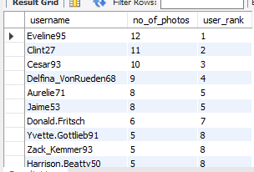

**8) Display the username of each user along with the creation date of**

**their first posted photo and the creation date of their next posted photo.**

**select username, created_at,**

**lag(created_at) over (order by created_at) as first_post,**

**lead(created_at) over (order by created_at) as next_post from users;**

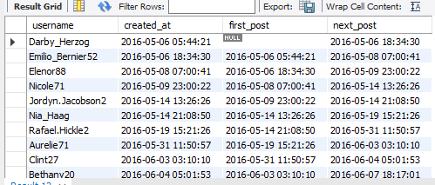

**9) For each comment, show the comment text, the username of the commenter,**

**and the comment text of the previous comment made on the same photo.**

**SELECT**

**u.username AS commenter_username,**

**c.comment_text AS comment_text,**

**LAG(c.comment_text) OVER (PARTITION BY c.photo_id ORDER BY c.id) AS previous_comment_text**

**FROM**

**comments c**

**JOIN**

**users u ON c.user_id = u.id**

**ORDER BY**

**c.photo_id, c.id;**

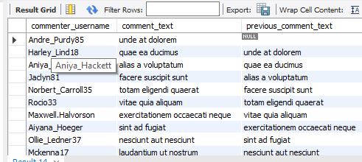

**10) Show the username of each user along with the number of photos they have posted and the number of photos posted by the user before them and after them, based on the creation date.**

**SELECT**

**u.username,**

**p.num_photos AS photos_posted,**

**LAG(p.num_photos) OVER (ORDER BY u.created_at) AS prev_photos,**

**LEAD(p.num_photos) OVER (ORDER BY u.created_at) AS next_photos**

**FROM users u**

**JOIN (**

**SELECT**

**user_id,**

**COUNT(*) AS num_photos**

**FROM photos**

**GROUP BY user_id**

**) p ON u.id = p.user_id**

**ORDER BY u.created_at;**

